**STUDENT PLACEMENT CHANCE PREDICTION USING ANN**

A Major Project work submitted in partial fulfillment of the requirements for the award of the Degree of

**BACHELOR OF TECHNOLOGY**

**in**

**ELECTRONICS AND COMMUNICATION ENGINEERING**

**by**

**B.SUMITH BABU 17H61A04D1**

**G.ARJUN KUMAR 17H61A04D7**

**J.SUJATHA 18H65A0426**

#### Under the guidance of

#### B.SANTHOSH KUMAR

Assistant Professor

Department of ECE



**DEPARTMENT OF ELECTRONICS AND COMMUNICATION ENGINEERING**

**ANURAG GROUP OF INSTITUTIONS**

**AUTONOMOUS**

**SCHOOL OF ENGINEERING**

**(Affiliated to Jawaharlal Nehru Technological University, Hyderabad)**

Venkatapur(V), Ghatkesar (M), Medchal Dist, Telangana-500088.

2020 – 2021

**ANURAG GROUP OF INSTITUTIONS**

**AUTONOMOUS**

**SCHOOL OF ENGINEERING**

**(Affiliated to Jawaharlal Nehru Technological University, Hyderabad)**

Venkatapur(V), Ghatkesar (M), Medchal Dist, Telangana-500088.

2017 – 2021

**DEPARTMENT OF ELECTRONICS AND COMMUNICATION ENGINEERING**



**CERTIFICATE**

This is to certify that this project report entitled **”STUDENT PLACEMENT CHANCE PREDICTION USING ANN”** being submitted by

**B.SUMITH BABu 17H61A04D1**

**G.ARJUN KUMAR 17H61A04D7**

**J.SUJATHA 18H65A0426**

in partial fulfillment for the award of the Degree of Bachelor of Technology in Electronics & Communication Engineering to the Jawaharlal Nehru Technological University, Hyderabad is a record of bonafide work carried out under my guidance and supervision. The results embodied in this project report have not been submitted to any other University or Institute for the award of any Degree or Diploma.

**B.SANTHOSH KUMAR DR. S.SATHEES KUMARAN**

Assistant Professor Head of the Department

Department of ECE Department of ECE

**External Examiner**

**ACKNOWLEDGEMENT**

This project is an acknowledgement to the inspiration, drive and technical assistance contributed by many individuals. This project would have never seen light of this day without the help and guidance we have received. We would like to express our gratitude to all the people behind the screen who helped us to transform an idea into a real application.

It’s our privilege and pleasure to express our profound sense of gratitude to **B. SANTHOSH KUMAR,** Assistant Professor, Department of ECE for his guidance throughout this dissertation work.

We express my sincere gratitude to **Dr. S. SATHEESKUMARAN**, Head of Department of Electronics and Communication Engineering for his precious suggestions for the successful completion of this project. He is also a great source of inspiration to our work.

We would like to express my deep sense of gratitude to **Dr. K. S. RAO**, Director of Anurag Group of Institutions for his tremendous support, encouragement and inspiration.

Lastly, we thank almighty, our parents, friends for their constant encouragement without which this assignment would not be possible. We would like to thank all the other staff members, teaching and non- teaching, which have extended their timely help and eased my work.

**BY**

**B. SUMITH BABu 17H61A04D1**

**G. ARJUN KUMAR 17H61A04D7**

**J.SUJATHA 18H65A0426**

**DECLARATION**

We hereby declare that the result embodied in this project report entitled “**STUDENT PLACEMENT CHANCE PREDICTION USING ANN**” is carried out by us during the year 2020-2021 for the partial fulfillment of the award of **Bachelor of Technology** in **Electronics and Communication Engineering,** from ANURAG GROUP OF INSTITUTIONS. We have not submitted this project report to any other Universities / Institute for the award of any degree.

**BY**

**BARE SUMITH BABU 17H61A04D1**

**GANDLA ARJUN KUMAR 17H61A04D7**

**JARPULAVATH SUJATHA 18H65A0426**

**ABSTRACT**

All students dream to obtain a job offer in their hands before they leave their college. A placement chance predictor helps students to have an idea about where they stand and what to be done to obtain a good placement. A placement predictor is a system that could predict the possibility or the type of company a pre-final year student has chances to be placed. Thus a prediction system could help in the academic planning of an institution for future years. With the emergence of Data mining and Deep learning, many predictor models were introduced by analyzing the current year student’s dataset. This project presents an approach for using deep learning algorithm to make a placement prediction model for pre-final year engineering graduate students.

**LIST OF CONTENTS**

**Name Page No.**

**ABSTRACT v**

**LIST OF FIGURE vii**

**LIST OF TABLES viii**

**LIST OF ABBRIVATION ix**

**1. INTRODUCTION 1**

**2. LITERATURE SURVEY 2**

**3. SOFTWARE REQUIRED 4**

3.1 Introduction to Python 4

3.1.1 Features of Python 4

3.1.2 How to setup Python 6

3.1.3 Installation 6

3.2 HTML5 7

3.2.1 Introduction 7

3.2.2 Feature 7

3.2.3 New elements 8

3.2.4 Advantages 10

3.2.5 Disadvantages 10

3.3 CSS 10

3.4 JavaScript 11

3.4.1 Why to learn 11

3.4.2 Application 11

3.5 MySQL 12

**4. Artificial neural network 14**

4.1 Introduction to Neural Network 14

4.2 Components of ANN 15

4.3 Multi-Layer Perceptron 16

4.3 Data sets 17

**5.** **METHODOLOGY 19**

5.1 Proposed Method 19

5.2 System Designs 20

5.2.1 UML Diagrams 20

**LIST OF CONTENT**

**Name Page No.**

**6. RESULT 28**

6.1 Validation test 28

6.2 Screen Shots 28

**7. CONCLUSION AND FUTURE SCOPE 37**

**8. REFERENCES 38**

**9. APPENDIX 39**

**LIST OF FIGURES**

**Figure Name Page No.**

**Fig 4.1** Neurons 15

**Fig 4.2** Notations 16

**Fig 4.3** Dimensions 16

**Fig 4.2** Multi-layer Perceptrons 17

**Fig 4.3** Dataset 18

**Fig 5.1** Proposed Method 19

**Fig 5.2** Use Case Diagram 23

**Fig 5.3** Sequence Diagram 25

**Fig 5.4** Collaborative Diagram 25

**Fig 5.5** Activity Diagram 26

**Fig 6.1** Home page 28

**Fig 6.2** Admin login 29

**Fig 6.3** Admin home 29

**Fig 6.4** Upload datasets 30

**Fig 6.5** View datasets 30

**Fig 6.6** Upload questions 31

**Fig 6.7** View questions 31

**Fig 6.8** Student registration 32

**Fig 6.9** Student login page 32

**Fig 6.10** Student home page 33

**Fig 6.11**  Student exam page 33

**Fig 6.12** Sample exam paper 34

**Fig 6.13** Placement prediction 34

**Fig 6.14** Prediction result 35

**Fig 6.15** Placement details in admin side 35

**Fig 6.16** Prediction details in database 36

**Fig 6.17** Student login details 36

**LIST OF TABLES**

**Table No. Name Page No.**

**Table 3.1** Removed elements in HTML5 7

**Table 6.1** Test Cases 27

**LIST OF ABBREVIATION**

UML - Unified Modeling Language

HTML5 - Hyper Text Markup Language 5

CSS - Cascading Style Sheet

RDBMS - Relational Database Management System

ANN - Artificial Neural Network

MLP - Multi-level Perceptrons

**CHAPTER 1**

**INTRODUCTION**

According to statistics 1.5 million engineers are graduating each year in India. The demand and need for qualified graduates in field of IT industry is rising day by day. But most of the students are unaware about the needs of the IT industry. The number of the student graduates who satisfies the requirements and quality of a company is very low. Placements are one of the biggest challenge faced by a student in the lifetime. It is the responsibility of the institutions to provide maximum placement chance to its students. Also the placement cell and teachers of an institute should take proper steps in order to produce a set of students suitable for each company’s requirements. A placement prediction system can be used to identify the capability of a particular student for the specified job.

All companies in the IT sector spends a large amount of its total capital in recruiting the students to its company. Thus it is necessary to find an alternative process of filtering to reduce the capital cost that is used for this process. Effective filtering of students could be performed by applying various data mining and machine learning tools on the student details. Luan [1] defined the meaning of data mining in the field of education as a method of identifying, discovering and capturing the unknown similarities or patterns from a dataset by using an ensemble combination of various analytical approaches. It is possible for an educational institute to exploit this data mining feature to figure out the recruitment policy of a company from previous year placement statistics and student dataset. So the placement cell of the institution could prepare a placement predicted list for the present students. Thus it is very important to conduct a study on various placement prediction systems.

**CHAPTER 2**

**LITERATURE SURVEY**

“Data Mining Approach for Predicting Student and Institution’s Placement Percentage”, Professor. Ashok M Assistant Professor Apoorva A, 2016 International Conference on Computational Systems and Information Systems for Sustainable Solutions In this paper author has used the data mining technique for the prediction of the student’s placement. For the prediction of student’s placement author has divided the data into the two segments, first segment is the training segment which is historic data of passed out students. Another segment consists of current data of students, based on the historic data author has designed the algorithm for calculating the placement chances. Author has used the various data mining algorithms such as decision tree, I Bayes, neural network and the prosed algorithm were applied, and decision are made with the help of confusion matrix.

“Student Placement Analyzer: A Recommendation System Using Machine Learning”, Senthil Kumar Thangavel , Divya Bharathi P, Abijith Sankar, International Conference on Advanced Computing and Communication Systems (ICACCS -2017), Jan. 06 – 07, 2017, Coimbatore, INDIA In this paper author is concern about the challenges face by any institute regarding the placement. The placement prediction is very complex when the number of the entities increases in any institute. With the help of machine learning this complex problem of prediction can be easily solved. In this paper all the academic record of student is taken into consideration. Various classification and data making algorithms are used such as Naïve Bayes, Decision Tree, SVM and Regressions. After the prediction of the students can be placed in of the given category that is Core Company, dream company or support services.

“A Placement Prediction System Using Knearest Neighbors Classifier”, Animesh Giri, M Vignesh V Bhagavath, Bysani Pruthvi, Naini Dubey, Second International Conference on Cognitive Computing and Information Processing (CCIP), 2016 The placement prediction system predicts the probability of students getting placed in various companies by applying K-Nearest Neighbors classification. The result obtained is also compared with the results obtained from other machine learning models like Logistic Regression and SVM. The academic history of student along with their skill sets like programming skills, communication skills, analytical skills and team work is considered which is tested by companies during recruitment process. Data of past two batches are taken for this system.

“Class Result Prediction using Machine Learning”, Pushpa S K, Associate Professor, Manjunath T N, Professor and Head, Mrunal T V, Amartya Singh, C Suhas, International Conference On Smart Technology for Smart Nation, 2017 In this paper, the result of a class is predicted using machine learning. Performance of students in past semester along with scores of internal examinations of the current semester is considered to predict whether the student passes or fails in the current semester before attempting the final examination. The author uses SVM, I Bayes, Random Forest Classifier and Gradient Boosting to compute the result. Boosting is an ensemble learning algorithm which combines various learning algorithm to obtain better predictive performance.

“Student Placement Analyzer : A Recommendation System Using Machine Journal of Emerging Technologies and Innovative Research (JETIR) www.jetir.org 1013 Learning”, Apoorva Rao R, Deeksha K C, Vishal Prajwal R, Vrushak K, Nandini, JARIIE-ISSN(O)- 2395-4396 Now-a-days institutions are facing many challenges regarding student placements. For educational institutions it is much difficult task to keep record of every single student and predict the placement of student manually. To overcome these challenges, concept of machine learning and various algorithms are explored to predict the result of class students. For this purpose, training data set is historical data of past students and this is used to train the model. This software system predicts placement status in 5 categories viz dream company, core company, mass recruiter, not eligible and not interested in placements. This system is also helpful to weaker students. Institutions can provide extra care towards weaker students so that they can improve their performance. By use Naïve Bayes algorithm all the data will be monitor and appropriate decision will be provided

used energy physics for the particle collision analysis in energy physics which has shown great results. Therefore, CNNs have proved very efficient in classification tasks used in Deep Learning.

**CHAPTER 3**

**SOFTWARE REQUIREMENT**

Operating System : Windows 10

Technology : Python 3.6

Web Technologies :          Html5, JavaScript, CSS.

Web Server :          Tomcat 7/8

Database :          MySQL

**3.1 Python:**

**3.1.1. Introduction to python:**

Python is an interpreter, high-level, general-purpose programming language. Created by Guido van Rossum and first released in 1991, Python’s design philosophy emphasizes code readability with its notable use of significant whitespace. Its language constructs and object oriented approach aim to help programmers write clear, logical code for small and large-scale projects

Python is dynamically typed and garbage-collected. It supports multiple programming paradigms, including structured (particularly, procedural), object-oriented, and functional programming. Python is often described as a “batteries included” language due to its comprehensive standard library.

**3.1.2 FEATURES OF PYTHON:**

Python provides many useful features which make it popular and valuable from the other programming languages. It supports object-oriented programming; procedural programming approaches and provides dynamic memory allocation. We have listed below a few essential features.

**Easy to Learn and Use**

Python is easy to learn as compared to other programming languages. Its syntax is straightforward and much the same as the English language. There is no use of the semicolon or curly-bracket, the indentation defines the code block. It is the recommended programming language for beginners.

**Expressive Language**

Python can perform complex tasks using a few lines of code. A simple example, the hello world program you simply type print(“Hello World”). It will take only one line to execute, while Java or C takes multiple lines. The open-source means, “Anyone can download its source code without paying any penny.”

**Object-Oriented Language**

Python supports object-oriented language and concepts of classes and objects come into existence. It supports inheritance, polymorphism, and encapsulation, etc. The object-oriented procedure helps to programmer to write reusable code and develop applications in less code.

**Extensible**

It implies that other languages such as C/C++ can be used to compile the code and thus it can be used further in our Python code. It converts the program into byte code, and any platform can use that byte code.

**Large Standard Library**

It provides a vast range of libraries for the various fields such as machine learning, web developer, and also for the scripting. There are various machine learning libraries, such as Tensor flow, Pandas, NumPy, Keras, and Pytorch, etc. Django, flask, pyramids are the popular framework for Python web development.

**GUI Programming Support**

Graphical User Interface is used for the developing Desktop application. PyQT5, Tkinter, Kivy are the libraries which are used for developing the web application.

**Integrated**

It can be easily integrated with languages like C, C++, and JAVA, etc. Python runs code line by line like C, C++ Java. It makes easy to debug the code.

**Embeddable**

The code of the other programming language can use in the Python source code. We can use Python source code in another programming language as well. It can embed other language into our code.

**Dynamic Memory Allocation**

In Python, we don’t need to specify the data-type of the variable. When we assign some value to the variable, it automatically allocates the memory to the variable at runtime. Suppose we are assigned integer value 15 to x, then we don’t need to write int x = 15. Just write x = 15.

**Interpreted Language**

Python is an interpreted language; it means the Python program is executed one line at a time. The advantage of being interpreted language, it makes debugging easy and portable.

**Cross-platform Language**

Python can run equally on different platforms such as Windows, Linux, UNIX, and Macintosh, etc. So, we can say that Python is a portable language. It enables programmers to develop the software for several competing platforms by writing a program only once.

**Free and Open Source**

Python is freely available for everyone. It is freely available on its official website www.python.org. It has a large community across the world that is dedicatedly working towards make new python modules and functions. Anyone can contribute to the Python community. The open-source means, “Anyone can download its source code without paying any penny.”

**3.3 HOW TO SETUP PYTHON:**

* Python is available on a wide variety of platforms including Linux and Mac OS X. Let’s understand how to set up our Python environment.
* The most up-to-date and current source code, binaries, documentation, news, etc., is available on the official website of Python.

**3**.**3.1 Installation(using python IDLE)**:

* Installing python is generally easy, and nowadays many Linux and Mac OS distributions include a recent python.
* Download python from www.python.org
* When the download is completed, double click the file and follow the instructions to install it.
* When python is installed, a program called IDLE is also installed along with it. It provides a graphical user interface to work with python
* Go to the file where your project is to be stored and select the path of the folder and type cmd then click enter.
* Command prompt will appears, next type jupyter notebook and click enter
* Jupyter notebook will be opened default browser.

**3.2 HTML**

**3.2.1 Introduction:**

HTML stands for Hyper Text Markup Language. It is used to design web pages using markup language. HTML is the combination of Hypertext and Markup language. Hypertext defines the link between the web pages. Markup language is used to define the text document within tag which defines the structure of web pages. HTML 5 is the fifth and current version of HTML. It has improved the markup available for documents and has introduced application programming interfaces(API) and Document Object Model(DOM).

**3.2.2 Features:**

* It has introduced new multimedia features which supports audio and video controls by using <audio> and <video> tags.
* There are new graphics elements including vector graphics and tags.
* Enrich semantic content by including <header> <footer>, <article>, <section> and <figure> are added.
* Drag and Drop- The user can grab an object and drag it further dropping it on a new location.
* Geo-location services- It helps to locate the geographical location of a client.
* Web storage facility which provides web application methods to store data on web browser.
* Uses SQL database to store data offline.
* Allows to draw various shapes like triangle, rectangle, circle, etc.
* Capable of handling incorrect syntax.
* Easy DOCTYPE declaration i.e. <!doctype html>
* Easy character encoding i.e. <meta charset=”UTF-8″>

**Removed elements from HTML 5:** There are many elements which are depreciated from HTML 5 are listed below:

**Table 3.1** Removed elements in HTML5

|  |  |
| --- | --- |
| Removed Elements | Use Instead Elements |
| <acronym> | <abbr> |
| <applet> | <object> |
| <basefont> | CSS |
| <big> | CSS |
| <center> | CSS |
| <dir> | <ul> |
| <font> | CSS |
| <frame> |  |
| <frameset> |  |
| <noframes> |  |
| <isindex> |  |
| <strike> | CSS, <s> or <del> |
| <tt> | CSS |

**3.2.3 New Added Elements in HTML** **5**:

* <article>: The <article> tag is used to represent an article. More specifically, the content within the <article> tag is independent from the other content of the site (even though it can be related).
* <aside>: The <aside> tag is used to describe the main object of the web page in a shorter way like a highlighter. It basically identifies the content that is related to the primary content of the web page but does not constitute the main intent of the primary page. The <aside> tag contains mainly author information, links, related content and so on.
* <figcaption>: The <figurecaption> tag in HTML is used to set a caption to the figure element in a document.
* <figure>: The <figure> tag in HTML is used to add self-contained content like illustrations, diagrams, photos or codes listing in a document. It is related to main flow but it can be used in any position of a document and the figure goes with the flow of the document and if remove it then it should not affect the flow of the document.
* <header>: It contains the section heading as well as other content, such as a navigation links, table of contents, etc.
* <footer>: The <footer> tag in HTML is used to define a footer of HTML document. This section contains the footer information (author information, copyright information, carriers etc). The footer tag are used within body tag. The <footer> tag is new in the HTML 5. The footer elements require a start tag as well as an end tag.
* <main>: Delineates the main content of the body of a document or web app.
* <mark>: The <mark> tag in HTML is used to define the marked text. It is used to highlight the part of the text in the paragraph.
* <nav>: The <nav> tag is used to declaring the navigational section in HTML documents. Websites typically have sections dedicated to navigational links, which enables user to navigate the site. These links can be placed inside a nav tag.
* <section>: It demarcates a thematic grouping of content.
* <details>: The <details> tag is used for the content/information which is initially hidden but could be displayed if the user wishes to see it. This tag is used to create interactive widget which user can open or close it. The content of details tag is visible when open the set attributes.
* <summary>: The <summary> tag in HTML is used to define a summary for the <details> element. The <summary> element is used along with the <details> element and provides a summary visible to the user. When the summary is clicked by the user, the content placed inside the <details> element becomes visible which was previously hidden. The <summary> tag was added in HTMl 5. The <summary> tag requires both starting and ending tag.
* <time>: The <time> tag is used to display the human-readable data/time. It can also be used to encode dates and times in a machine-readable form. The main advantage for users is that they can offer to add birthday reminders or scheduled events in their alidati’s and search engines can produce smarter search results.
* <bdi>: The <bdi> tag refers to the Bi-Directional Isolation. It differentiate a text from other text that may be formatted in different direction. This tag is used when a user generated text with an unknown directions.
* <wbr>: The <wbr> tag in HTML stands for word break opportunity and is used to define the position within the text which is treated as a line break by the browser. It is mostly used when the used word is too long and there are chances that the browser may break lines at the wrong place for fitting the text.
* <datalist>: The <datalist> tag is used to provide autocomplete feature in the HTML files. It can be used with input tag, so that users can easily fill the data in the forms using select the data.
* <keygen>: The <keygen> tag in HTML is used to specify a key-pair generator field in a form. The purpose of <keygen> element is to provide a secure way to authenticate users. When a from is submitted then two keys are generated, private key and public key. The private key stored locally, and the public key is sent to the server. The public key is used to generate client certificate to authenticate user for future.
* <output>: The <output> tag in HTML is used to represent the result of a calculation performed by the client-side script such as JavaScript.
* <progress>: It is used to represent the progress of a task. It is also define that how much work is done and how much is left to download a things. It is not used to represent the disk space or relevant query.
* <svg>: It is the Scalable Vector Graphics.
* <canvas>: The <canvas> tag in HTML is used to draw graphics on web page using JavaScript. It can be used to draw paths, boxes, texts, gradient and adding images. By default it does not contains border and text.
* <audio>: It defines the music or audio content.
* <embed>: Defines containers for external applications (usually a video player).
* <source>: It defines the sources for <video> and <audio>.
* <track>: It defines the tracks for <video> and <audio>.
* <video>: It defines the video content.

**3.2.4 Advantages**:

* All browsers supported.
* More device friendly.
* Easy to use and implement.
* HTML 5 in integration with CSS, JavaScript, etc can help build beautiful websites.

**3.2.5 Disadvantages:**

* Long codes have to be written which is time consuming.
* Only modern browsers support it.

**3.3 CSS:**

**Cascading Style Sheets** (**CSS**) is a style sheet language used for describing the presentation of a document written in a markup language such as HTML. CSS is a cornerstone technology of the World Wide Web, alongside HTML and JavaScript.

CSS is designed to enable the separation of presentation and content, including layout, colors, and fonts. This separation can improve content accessibility, provide more flexibility and control in the specification of presentation characteristics, enable multiple web pages to share formatting by specifying the relevant CSS in a separate .css file which reduces complexity and repetition in the structural content as well as enabling the .css file to be cached to improve the page load speed between the pages that share the file and its formatting.

Separation of formatting and content also makes it feasible to present the same markup page in different styles for different rendering methods, such as on-screen, in print, by voice (via speech-based browser or screen reader), and on Braille-based tactile devices. CSS also has rules for alternate formatting if the content is accessed on a mobile device.

The name *cascading* comes from the specified priority scheme to determine which style rule applies if more than one rule matches a particular element. This cascading priority scheme is predictable.

The CSS specifications are maintained by the World Wide Web Consortium (W3C). Internet media type (MIME type) text/css is registered for use with CSS by RFC 2318 (March 1998). The W3C operates a free CSS validation service for CSS documents.

In addition to HTML, other markup languages support the use of CSS including XHTML, plain XML, SVG, and XUL.

**3.4 Javascript:**

**JavaScript** is a lightweight, interpreted **programming** language. It is designed for creating network-centric applications. It is complimentary to and integrated with Java. **JavaScript** is very easy to implement because it is integrated with HTML. It is open and cross-platform.

**3.4.1 Why to Learn Javascript**

* **Javascript** is a MUST for students and working professionals to become a great Software Engineer specially when they are working in Web Development Domain. I will list down some of the key advantages of learning Javascript:
* Javascript is the most popular **programming language** in the world and that makes it a programmer’s great choice. Once you learnt Javascript, it helps you developing great front-end as well as back-end softwares using different Javascript based frameworks like jQuery, Node.JS etc.
* Javascript is everywhere, it comes installed on every modern web browser and so to learn Javascript you really do not need any special environment setup. For example Chrome, Mozilla Firefox , Safari and every browser you know as of today, supports Javascript.
* Javascript helps you create really beautiful and crazy fast websites. You can develop your website with a console like look and feel and give your users the best Graphical User Experience.
* JavaScript usage has now extended to mobile app development, desktop app development, and game development. This opens many opportunities for you as Javascript Programmer.
* Due to high demand, there is tons of job growth and high pay for those who know JavaScript. You can navigate over to different job sites to see what having JavaScript skills looks like in the job market.
* Great thing about Javascript is that you will find tons of frameworks and Libraries already developed which can be used directly in your software development to reduce your time to market.

**3.4.2 Applications of Javascript Programming**

As mentioned before, Javascript is one of the most widely used programming languages (Front-end as well as Back-end). It has it’s presence in almost every area of software development. I’m going to list few of them here:

* Client side validation – This is really important to verify any user input before submitting it to the server and Javascript plays an important role in alidating those inputs at front-end itself.
* Manipulating HTML Pages – Javascript helps in manipulating HTML page on the fly. This helps in adding and deleting any HTML tag very easily using javascript and modify your HTML to change its look and feel based on different devices and requirements.
* User Notifications – You can use Javascript to raise dynamic pop-ups on the webpages to give different types of notifications to your website visitors.
* Back-end Data Loading – Javascript provides Ajax library which helps in loading back-end data while you are doing some other processing. This really gives an amazing experience to your website visitors.
* Presentations – JavaScript also provides the facility of creating presentations which gives website look and feel. JavaScript provides RevealJS and BespokeJS libraries to build a web-based slide presentations.
* Server Applications – Node JS is built on Chrome’s Javascript runtime for building fast and scalable network applications. This is an event based library which helps in developing very sophisticated server applications including Web Servers.

**3.5 MySQL:**

* **MySQL** is a relational database management system (RDBMS)[]](http://en.wikipedia.org/wiki/MySQL#cite_note-1) that runs as a server providing multi-user access to a number of databases.  The SQL phrase stands for Structured Query Language. Free-software-open source projects that require a full-featured database management system often use MySQL. For commercial use, several paid editions are available, and offer additional functionality. Applications which use MySQL databases include: TYPO3, Joomla, WordPress, phpBB, Drupal and other software built on the LAMP software stack. MySQL is also used in many high-profile, large scale WorldWideWeb products,includingWikipedia, Google  , Facebook, and Twitter.
* MySQL is the world’s most popular open source database software, with over 100 million copies of its software downloaded or distributed throughout it’s history. With its superior speed, reliability, and ease of use, MySQL has become the preferred choice for Web, Web 2.0, SaaS, ISV, Telecom companies and forward-thinking corporate IT Managers because it eliminates the major problems associated with downtime, maintenance and administration for modern, online applications.
* Many of the world’s largest and fastest-growing organizations use MySQL to save time and money powering their high-volume Web sites, critical business systems, and packaged software including industry leaders such as Yahoo!, Alcatel-Lucent, Google, Nokia, YouTube, Wikipedia, and Booking.com.
* The flagship MySQL offering is MySQL Enterprise, a comprehensive set of production-tested software, proactive monitoring tools, and premium support services available in an affordable annual subscription.
* MySQL is a key part of LAMP (Linux, Apache, MySQL, PHP / Perl / Python), the fast-growing open source enterprise software stack. More and more companies are using LAMP as an alternative to expensive proprietary software stacks because of its lower cost and freedom from platform lock-in.

**CHAPTER 4**

**ARTIFICIAL NEURAL NETWORK**

Artificial neural networks (ANNs), usually simply called neural networks (NNs), are computing systems inspired by the biological neural networks that constitute animal brains. An ANN is based on a collection of connected units or nodes called artificial neurons, which loosely model the neurons in a biological brain. Each connection, like the synapses in a biological brain, can transmit a signal to other neurons. An artificial neuron that receives a signal then processes it and can signal neurons connected to it. The “signal” at a connection is a real number, and the output of each neuron is computed by some non-linear function of the sum of its inputs. The connections are called edges. Neurons and edges typically have a weight that adjusts as learning proceeds. The weight increases or decreases the strength of the signal at a connection. Neurons may have a threshold such that a signal is sent only if the aggregate signal crosses that threshold. Typically, neurons are aggregated into layers. Different layers may perform different transformations on their inputs. Signals travel from the first layer (the input layer), to the last layer (the output layer), possibly after traversing the layers multiple times.

**4.1 Introduction to Neural network:**

Neural networks learn (or are trained) by processing examples, each of which contains a known “input” and “result,” forming probability-weighted associations between the two, which are stored within the data structure of the net itself. The training of a neural network from a given example is usually conducted by determining the difference between the processed output of the network (often a prediction) and a target output. This difference is the error. The network then adjusts its weighted associations according to a learning rule and using this error value. Successive adjustments will cause the neural network to produce output which is increasingly similar to the target output. After a sufficient number of these adjustments the training can be terminated based upon certain criteria. This is known as supervised learning.

Such systems “learn” to perform tasks by considering examples, generally without being programmed with task-specific rules. For example, in image recognition, they might learn to identify images that contain cats by analyzing example images that have been manually labeled as “cat” or “no cat” and using the results to identify cats in other images. They do this without any prior knowledge of cats, for example, that they have fur, tails, whiskers, and cat-like faces. Instead, they automatically generate identifying characteristics from the examples that they process

**4.2 Components of ANN:**

**Neurons:**

ANNs are composed of artificial neurons which are conceptually derived from biological neurons. Each artificial neuron has inputs and produces a single output which can be sent to multiple other neurons. The inputs can be the feature values of a sample of external data, such as images or documents, or they can be the outputs of other neurons. The outputs of the final output neurons of the neural net accomplish the task, such as recognizing an object in an image.

To find the output of the neuron, first we take the weighted sum of all the inputs, weighted by the weights of the connections from the inputs to the neuron. We add a bias term to this sum. This weighted sum is sometimes called the activation. This weighted sum is then passed through a (usually nonlinear) activation function to produce the output. The initial inputs are external data, such as images and documents. The ultimate outputs accomplish the task, such as recognizing an object in an image.

**Connections and weights:**

The network consists of connections, each connection providing the output of one neuron as an input to another neuron. Each connection is assigned a weight that represents its relative importance. A given neuron can have multiple input and output connections.

**Propagation function:**

The propagation function computes the input to a neuron from the outputs of its predecessor neurons and their connections as a weighted sum. A bias term can be added to the result of the propagation..

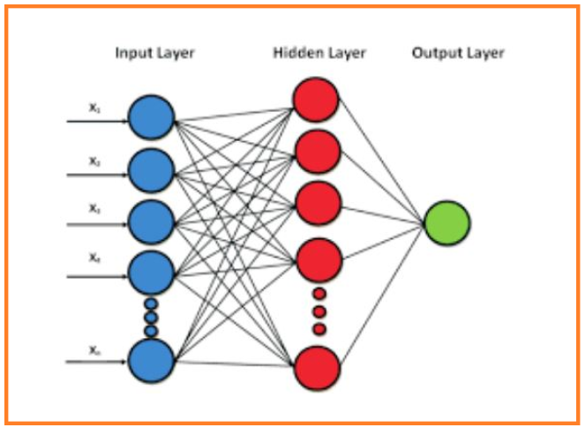

**Fig 4.1** Neurons

Output layer. Therefore, we can define neural network as information flows from inputs through hidden layers towards the output. For a 3-layers neural network, the learned function would be: f(x) = f_3(f_2(f_1(x))) where:

f_1(x): Function learned on first hidden layer

f_2(x): Function learned on second hidden layer

f_3(x): Function learned on output layer

Lets first introduce some notations that will be used throughout the document:

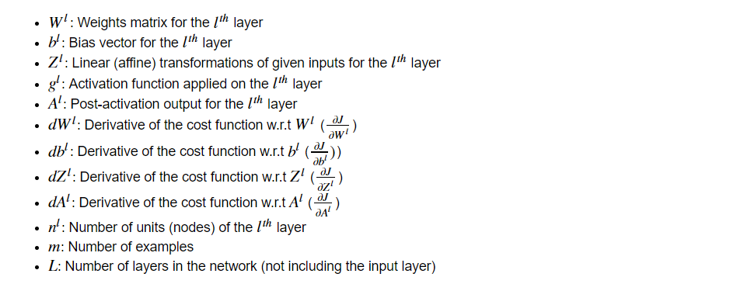

**Fig 4.2** Notations

Next, we’ll write down the dimensions of a multi-layer neural network in the general form to help us in matrix multiplication because one of the major challenges in implementing a neural network is getting the dimensions right.

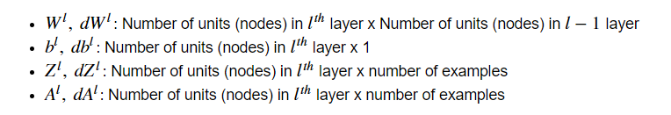

**Fig 4.3** Dimensions

**4.3 Multi-Layer Perceptrons**

* The field of artificial neural networks is often just called neural networks or multi-layer perceptrons after perhaps the most useful type of neural network. A perceptron is a single neuron model that was a precursor to larger neural networks.
* It is a field that investigates how simple models of biological brains can be used to solve difficult computational tasks like the predictive modeling tasks we see in machine learning. The goal is not to create realistic models of the brain, but instead to develop robust algorithms and data structures that we can use to model difficult problems.
* The power of neural networks come from their ability to learn the representation in your training data and how to best relate it to the output variable that you want to predict. In this sense neural networks learn a mapping. Mathematically, they are capable of learning any mapping function and have been proven to be a universal approximation algorithm.
* The predictive capability of neural networks comes from the hierarchical or multi-layered structure of the networks. The data structure can pick out (learn to represent) features at different scales or resolutions and combine them into higher-order features. For example from lines, to collections of lines to shapes.

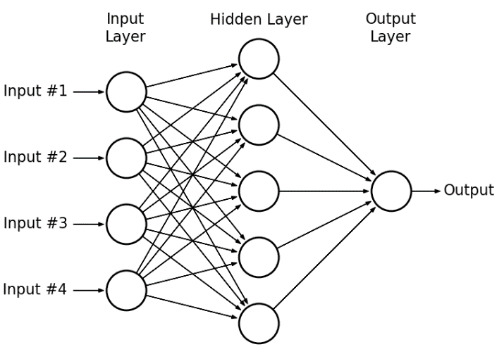

**Fig 4.4** Multi-Layer Perceptrons

**4.3 Dataset:**

In order to determine the placement prediction, we wanted to collect the real time data.

For that we have conducted the survey for the students. With the help of the survey we have send forms which contains the attributes like

* Coding Skills
* Aptitude Skills
* Technical Skills
* Projects
* Internships
* Academic Performance
* Placed

Based on all the above factors and the scores obtained in all the factor and the scores obtained in all the factors are collected and formed as a single data.

Again from the data obtained we have edited into a single sheet and to make the prediction much more easier we have removed the names from the tables at the end.

So based on the above process we have assigned the probability of placement prediction of the students.

With the help of the machine learning algorithms we can obtain high accuracy and easy prediction and analysis of the student can be done in much betterway the the normal traditional techniques.

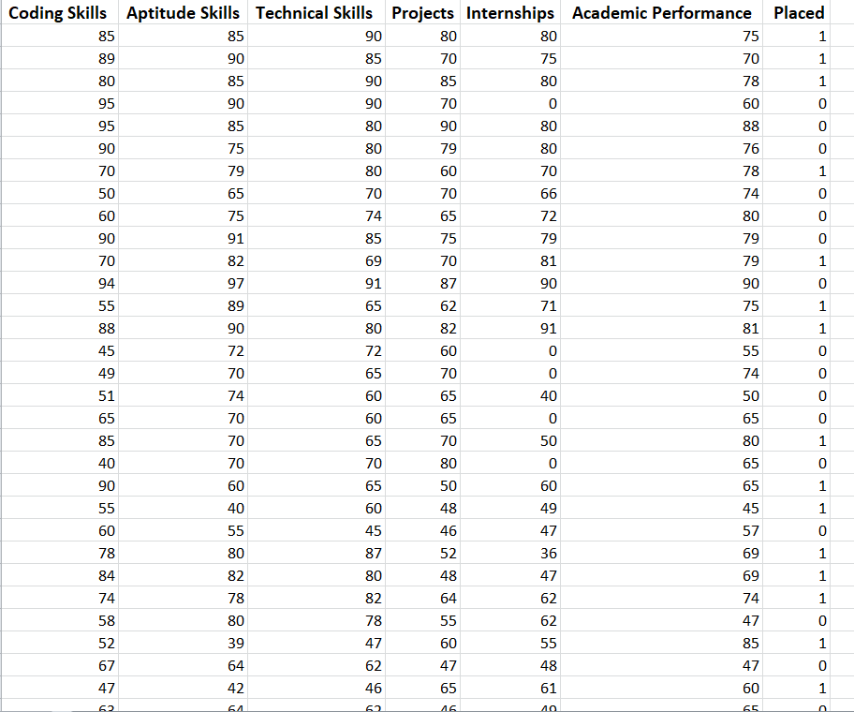

**Fig 4.5 Dataset**

**CHAPTER 5**

**METHODOLOGY**

**5.1 PROPOSED METHOD:**

All companies in the IT sector spend a large amount of its total capital in recruiting the students to its company. Thus it is necessary to find an alternative process of filtering to reduce the capital cost that is used for this process. Effective filtering of students could be performed by applying various deep learning tools on the student details. This system defined the meaning of deep learning in the field of education as a method of identifying, discovering and capturing the unknown similarities or patterns from a dataset by using an ensemble combination of various analytical approaches. It is possible for an educational institute to exploit this data mining feature to figure out the recruitment policy of a company from previous year placement statistics and student dataset. So the placement cell of the institution could prepare a placement predicted list for the present students. Thus it is very important to conduct a study on various placement prediction systems. This project presents a survey on different placement prediction system models and its application for the students.

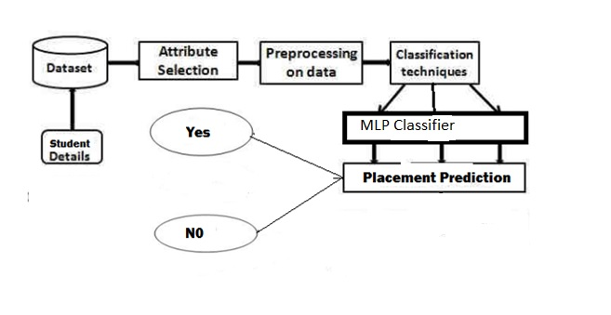

**Fig 5.1 Proposed Method**

**5.2 SYSTEM DESIGN**

**5.2.1 UML DIAGRAMS**

The System Design Document describes the system requirements, operating environment, system and subsystem architecture, files and database design, input formats, output layouts, human-machine interfaces, detailed design, processing logic, and external interfaces.

**Global Use Case Diagrams:**

Identification of actors:

**Actor:** Actor represents the role a user plays with respect to the system. An actor interacts with, but has no control over the use cases.

Graphical representation:

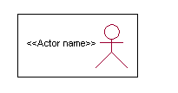

<<Actor name>>

An actor is someone or something that:

Interacts with or uses the system.

* Provides input to and receives information from the system.
* Is external to the system and has no control over the use cases.

Actors are discovered by examining:

* Who directly uses the system?
* Who is responsible for maintaining the system?
* External hardware used by the system.
* Other systems that need to interact with the system.

Questions to identify actors:

* + Who is using the system? Or, who is affected by the system? Or, which groups need help from the system to perform a task?
  + Who affects the system? Or, which user groups are needed by the system to perform its functions? These functions can be both main functions and secondary functions such as administration.
  + Which external hardware or systems (if any) use the system to perform tasks?
  + What problems does this application solve (that is, for whom)?
  + And, finally, how do users use the system (use case)? What are they doing with the system?

The actors identified in this system are:

1. **System Administrator**
2. **Customer**
3. **Customer Care**

Identification of usecases:

**Usecase:** A use case can be described as a specific way of using the system from a user’s (actor’s) perspective.

**Graphical representation:**



A more detailed description might characterize a use case as:

* Pattern of behavior the system exhibits
* A sequence of related transactions performed by an actor and the system
* Delivering something of value to the actor

Use cases provide a means to:

* capture system requirements
* communicate with the end users and domain experts
* test the system

Use cases are best discovered by examining the actors and defining what the actor will be able to do with the system.

Guide lines for identifying use cases:

* For each actor, find the tasks and functions that the actor should be able to perform or that the system needs the actor to perform. The use case should represent a course of events that leads to clear goal
* Name the use cases.
* Describe the use cases briefly by applying terms with which the user is familiar.

This makes the description less ambiguous

Questions to identify use cases:

* What are the tasks of each actor?
* Will any actor create, store, change, remove or read information in the system?
* What use case will store, change, remove or read this information?
* Will any actor need to inform the system about sudden external changes?
* Does any actor need to inform about certain occurrences in the system?
* What usecases will support and maintains the system?

**Flow of Events**

A flow of events is a sequence of transactions (or events) performed by the system. They typically contain very detailed information, written in terms of what the system should do, not how the system accomplishes the task. Flow of events are created as separate files or documents in your favorite text editor and then attached or linked to a use case using the Files tab of a model element.

A flow of events should include:

* When and how the use case starts and ends
* Use case/actor interactions
* Data needed by the use case
* Normal sequence of events for the use case
* Alternate or exceptional flows

**Construction of Usecase diagrams:**

Use-case diagrams graphically depict system behavior (use cases). These diagrams present a high level view of how the system is used as viewed from an outsider’s (actor’s) perspective. A use-case diagram may depict all or some of the use cases of a system.

A use-case diagram can contain:

* actors (“things” outside the system)
* use cases (system boundaries identifying what the system should do)
* Interactions or relationships between actors and use cases in the system including the associations, dependencies, and generalizations.

Relationships in use cases:

**1. Communication:**

The communication relationship of an actor in a usecase is shown by connecting the actor symbol to the usecase symbol with a solid path. The actor is said to communicate with the usecase.

**2. Uses:**

A Uses relationship between the usecases is shown by generalization arrow from the usecase.

**3. Extends:**

The extend relationship is used when we have one usecase that is similar to another usecase but does a bit more. In essence it is like subclass.

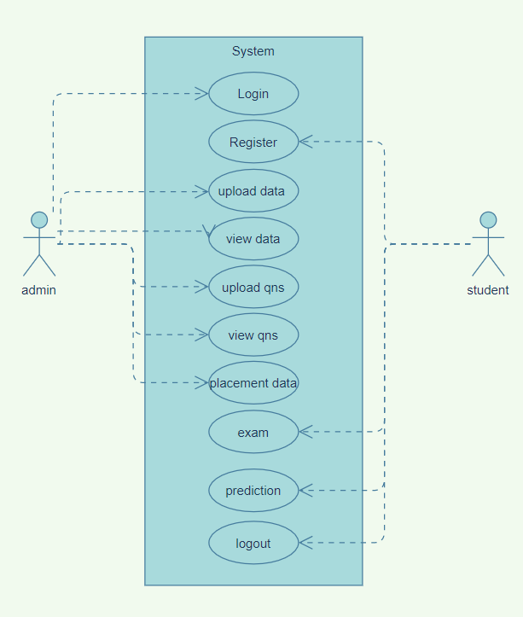

**Fig 5.2 Use Case Diagram**

**SEQUENCE DIAGRAMS**

A sequence diagram is a graphical view of a scenario that shows object interaction in a time-based sequence what happens first, what happens next. Sequence diagrams establish the roles of objects and help provide essential information to determine class responsibilities and interfaces.

There are two main differences between sequence and collaboration diagrams: sequence diagrams show time-based object interaction while collaboration diagrams show how objects associate with each other. A sequence diagram has two dimensions: typically, vertical placement represents time and horizontal placement represents different objects.

**Object:**

An object has state, behavior, and identity. The structure and behavior of similar objects are defined in their common class. Each object in a diagram indicates some instance of a class. An object that is not named is referred to as a class instance.

The object icon is similar to a class icon except that the name is underlined:

An object’s concurrency is defined by the concurrency of its class.

**Message:**

A message is the communication carried between two objects that trigger an event. A message carries information from the source focus of control to the destination focus of control. The synchronization of a message can be modified through the message specification. Synchronization means a message where the sending object pauses to wait for results.

**Link:**

A link should exist between two objects, including class utilities, only if there is a relationship between their corresponding classes. The existence of a relationship between two classes symbolizes a path of communication between instances of the classes: one object may send messages to another. The link is depicted as a straight line between objects or objects and class instances in a collaboration diagram. If an object links to itself, use the loop version of the icon

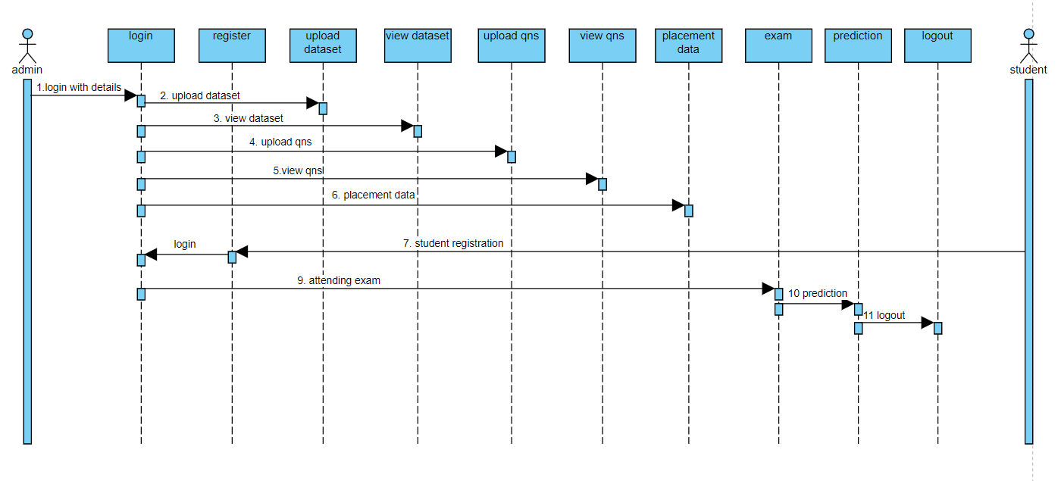

**Fig 5.3 Sequence Diagrams**

**COLLABORATION DIAGRAM:**

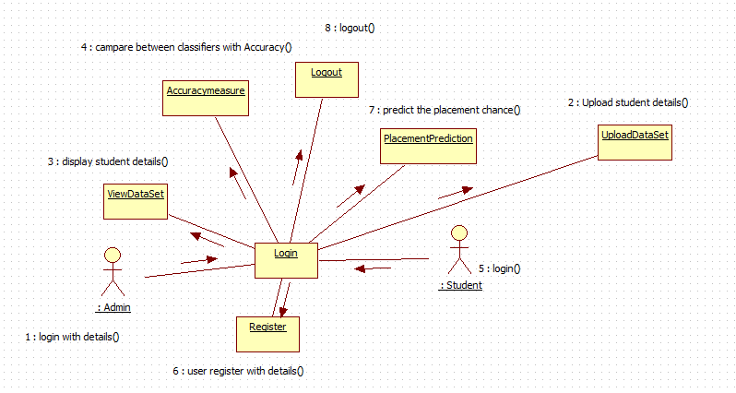

**Fig 5.4 collaboration diagram**

The collaboration diagram is used to show the relationship between the objects in a system. Both the sequence and the collaboration diagrams represent the same information but differently. Instead of showing the flow of messages, it depicts the architecture of the object residing in the system as it is based on object- oriented programming. An object consists of several features. Multiple objects present in the system are connected to each other. The collaboration diagram, which is also known as a communication diagram, is used to portray the object’s architecture in the system.

The collaborations are used when it is essential to depict the relationship between the object. Both the sequence and collaboration diagrams represent the same information, but the way of portraying it quite different. The collaboration diagrams are best suited for analyzing use cases.A Collaboration is a collection of named objects and actors with links connecting them. They collaborate in performing some task. A Collaboration defines a set of participants and relationships that are meaningful for a given set of purposes

**ACTIVITY DIAGRAM:**



**Fig 5.5 Activity Diagram**

Activity diagram is another important diagram in UML to describe the dynamic aspects of the system. Activity diagram is basically a flowchart to represent the flow from one activity to another activity. The activity can be described as an operation of the system. The control flow is drawn from one operation to another. This flow can be sequential, branched, or concurrent. Activity diagrams deal with all type of flow control by using different elements such as fork, join, etc

The basic purposes of activity diagrams is similar to other four diagrams. It captures the dynamic behavior of the system. Other four diagrams are used to show the message flow from one object to another but activity diagram is used to show message flow from one activity to another.

Activity is a particular operation of the system. Activity diagrams are not only used for visualizing the dynamic nature of a system, but they are also used to construct the executable system by using forward and reverse engineering techniques. The only missing thing in the activity diagram is the message part.

**CHAPTER 6**

**RESULTS**

**6.1 Validation Test Cases:**

**Test Case**

These are the conditions which user and admin has to follow to run application without any errors.

**Table 6.1** Test Cases

|  |  |  |  |
| --- | --- | --- | --- |
| SNO | Test Case | Input | Result |
| 1 | User Name | NULL | YES |
| 2 | Password | NULL | YES |
| 3 | User Name or Password | Invalid | Error Message |
| 4 | Upload Dataset | NULL | YES |
| 5 | Roll Number | NULL | YES |
| 6 | Password | NULL | YES |
| 7 | Name | NULL | YES |
| 8 | Email | NULL | YES |
| 9 | Email | Email Paten | Validation Message |
| 10 | Contact | NULL | YES |
| 11 | Contact | Max Numbers10 | Validation Message |
| 12 | Test Data set upload | NULL | YES |

**6.2 Screen Shots:**

These are the screenshots of individual web page created by in web application.

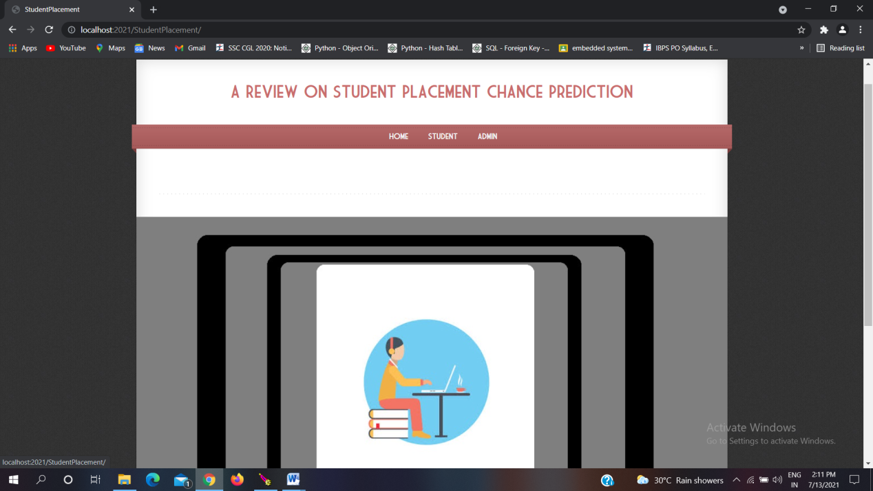

**Fig 6.1 Home Page**

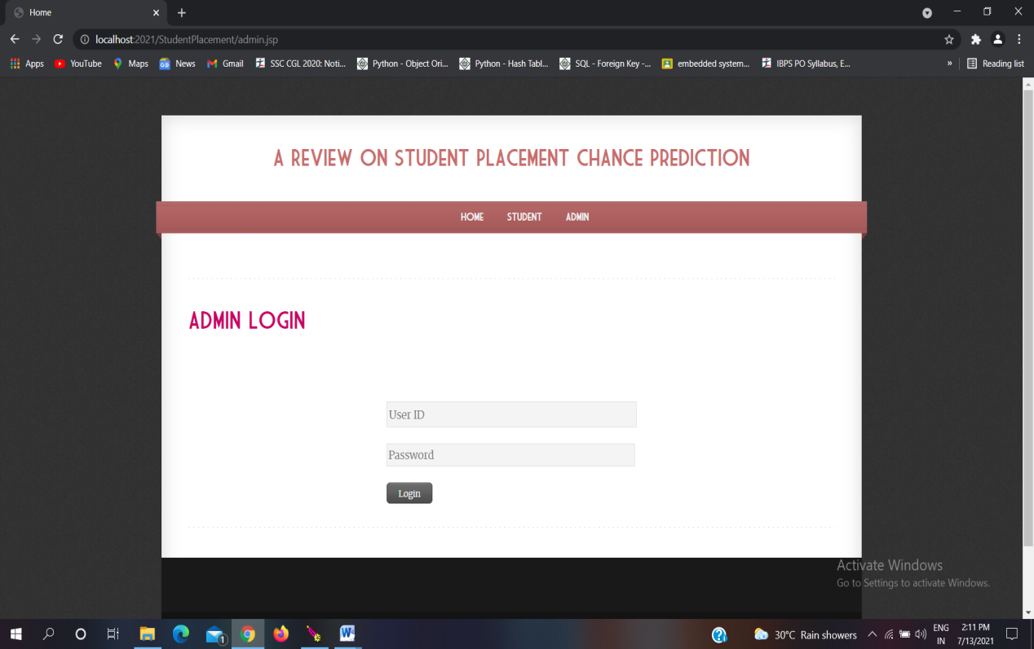

**Fig 6.2 Admin Login**

* The above page is to login from admin side with his login credentials.

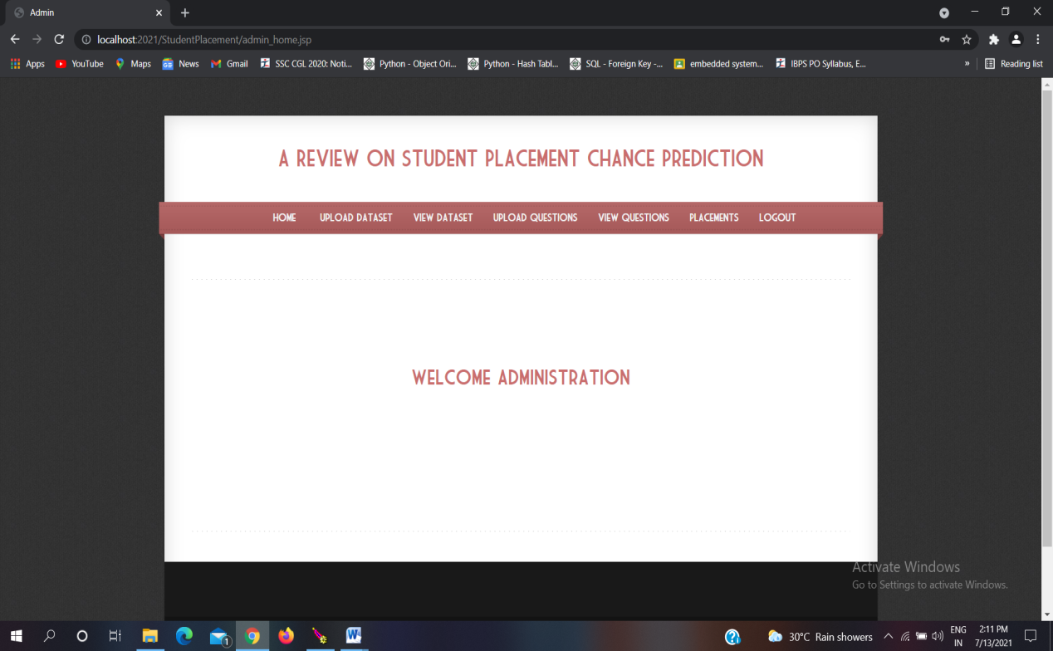

**Fig 6.3 Admin Home Page**

* The above page is the home page of admin login.

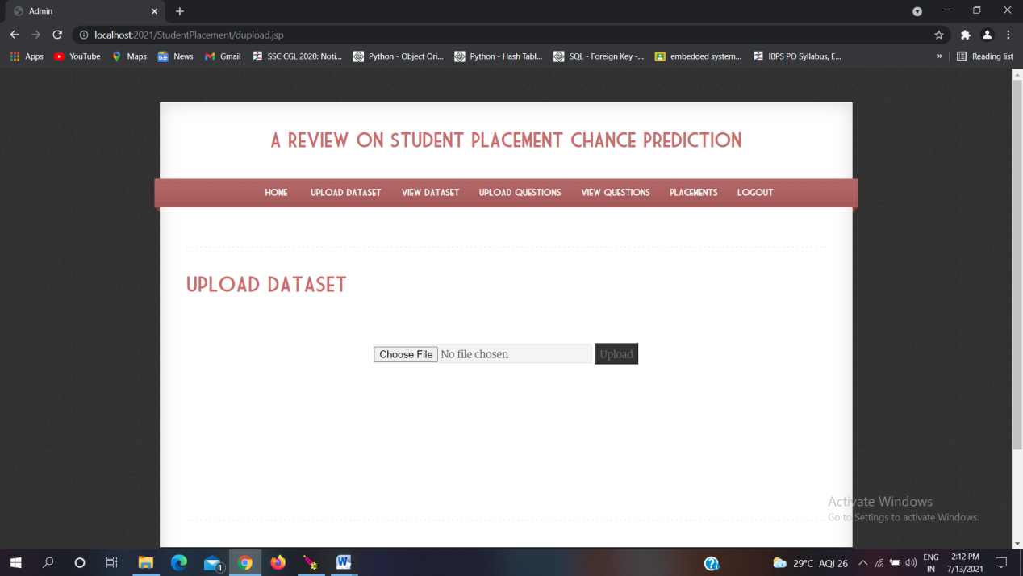

**Fig 6.4 Upload data set**

* The above page is to upload the dataset collected from the survey. Uploaded dataset is stored in mysql table.

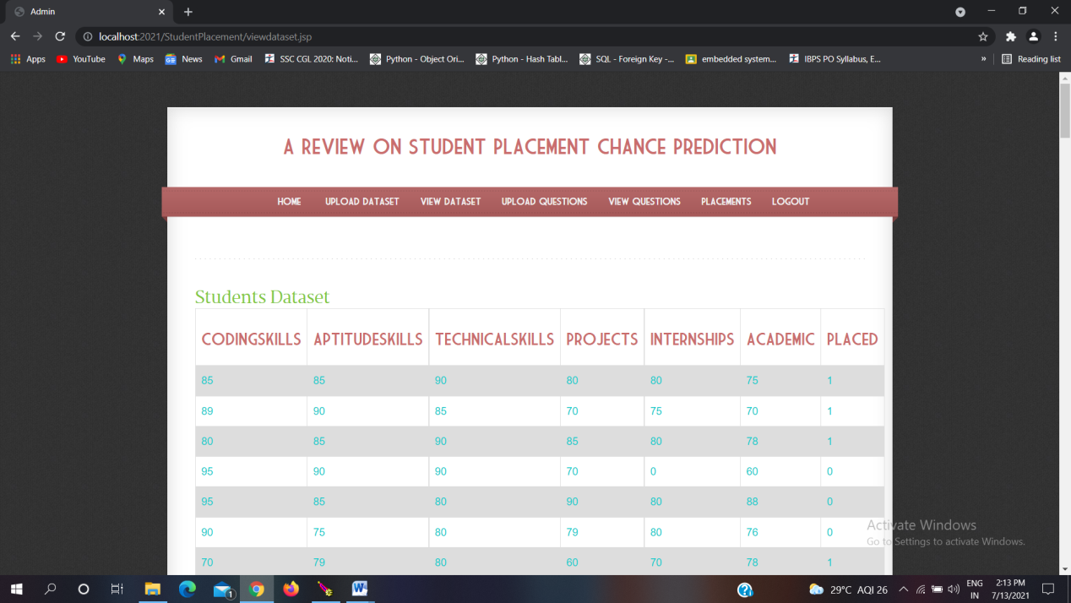

**Fig 6.5** view the uploaded dataset

* The above page is to view the dataset which is uploaded by admin collected from students in survey.

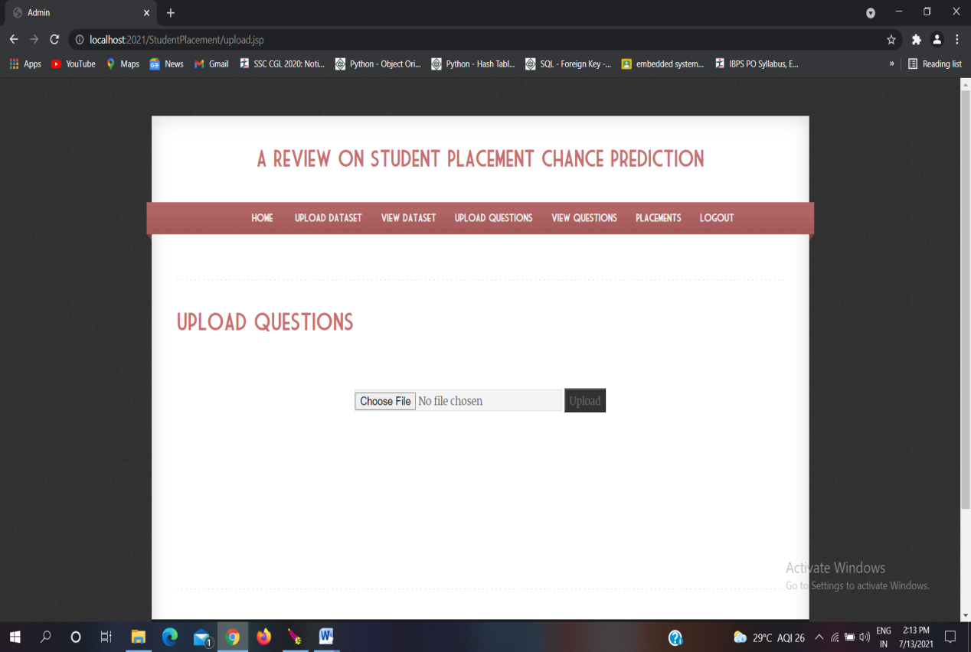

**Fig 6.6** Upload the questions

* The above page is to upload the questions for the exam to be conducted for students.

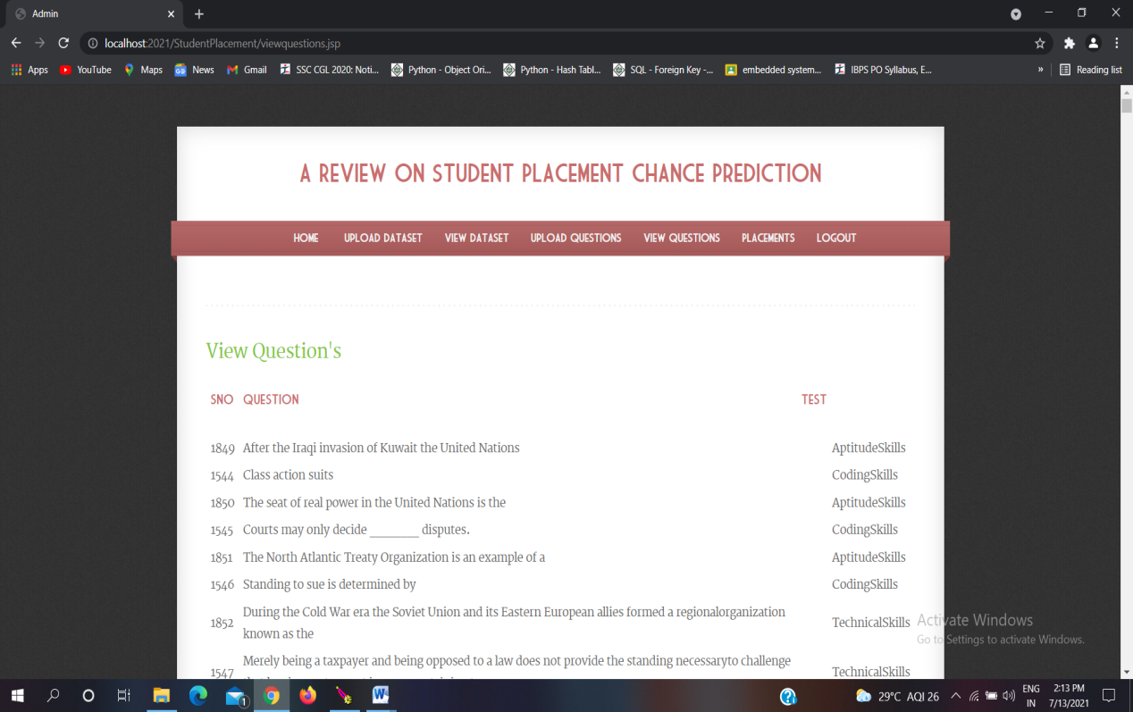

**Fig 6.7** view the uploaded questions

* The above page is to view the uploaded the questions for the exam to be conducted for students.

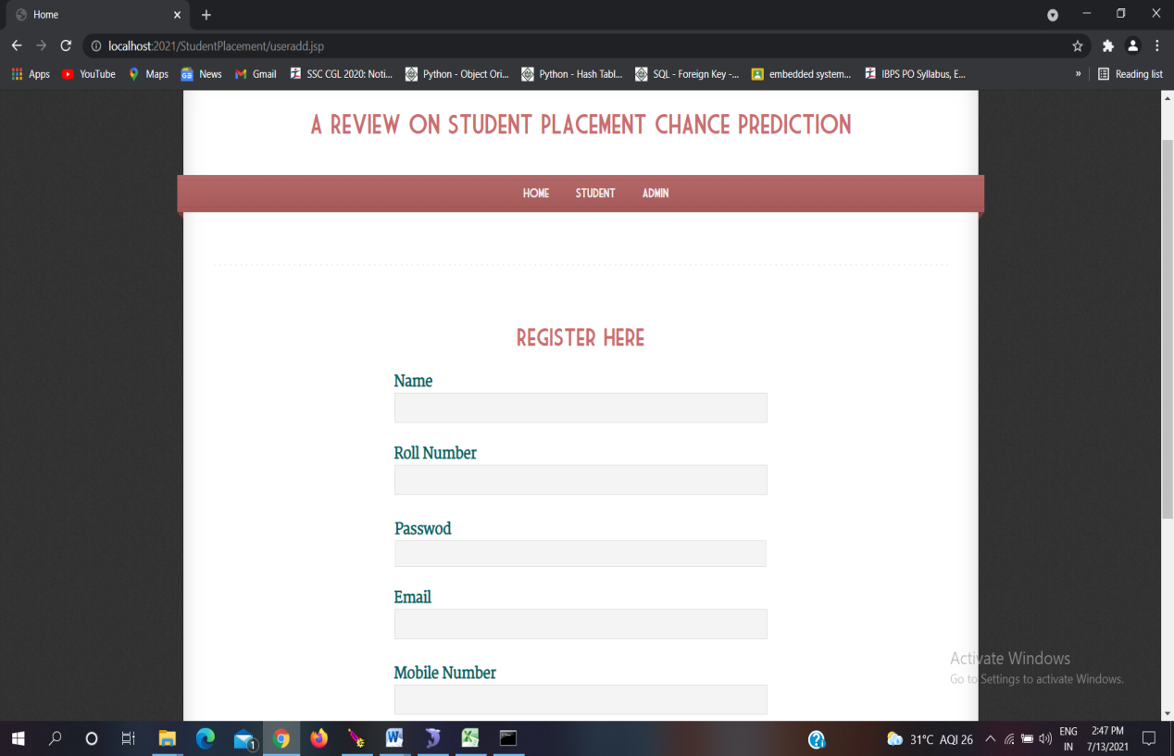

**Fig 6.8** Student registration form

* The above page is to registration for students who want to attend the exam.

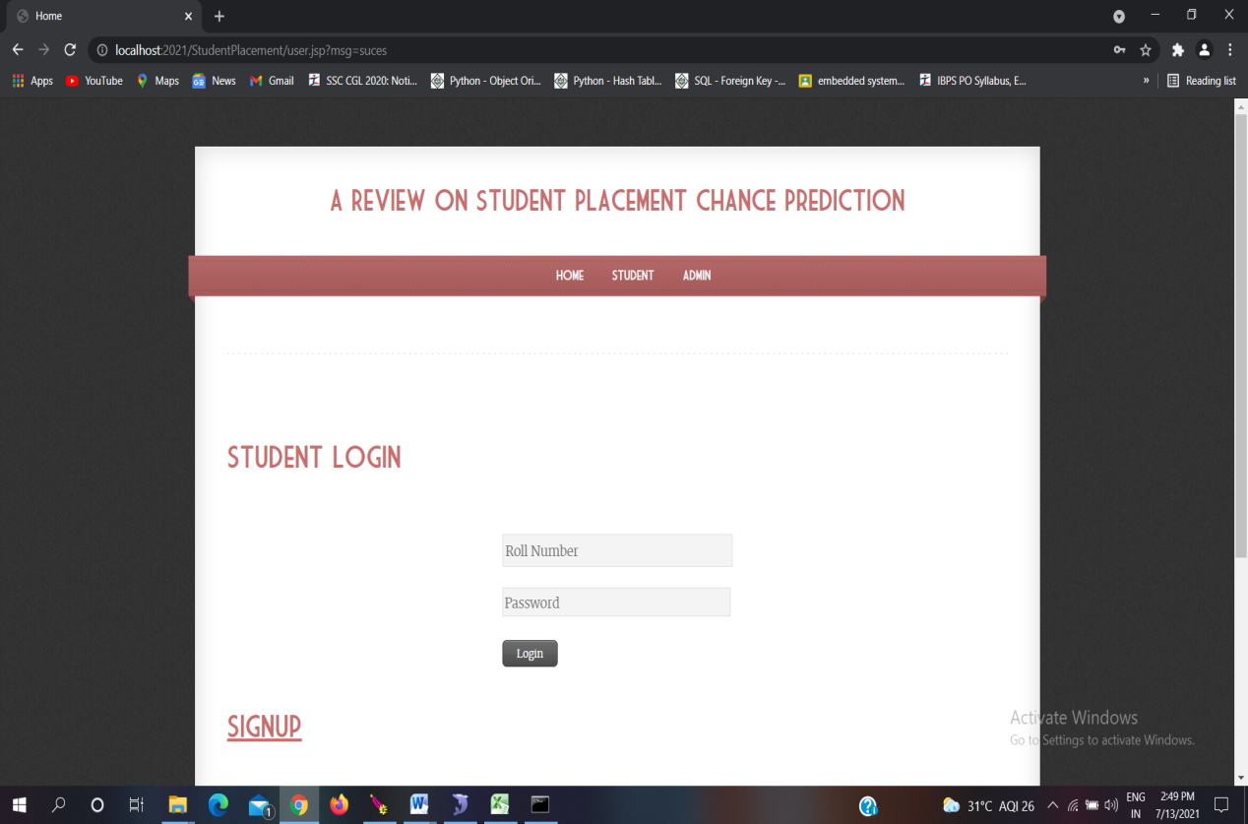

**Fig 6.9** Student Login

* The above page is for students to login with there roll number and password as there login credentials.

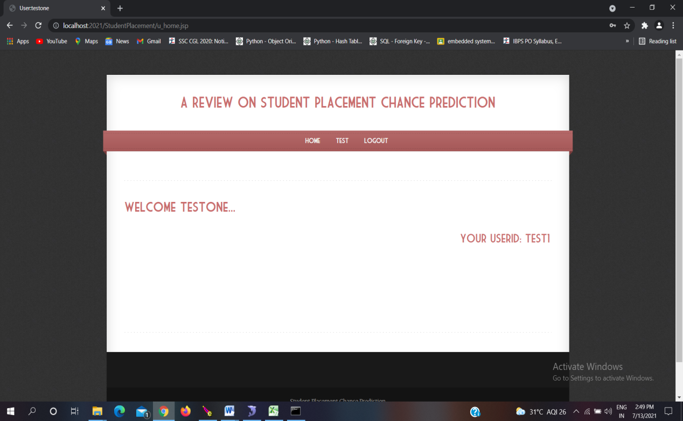

**Fig 6.10** Student Login Home Page

* The above page is the home page for student login.

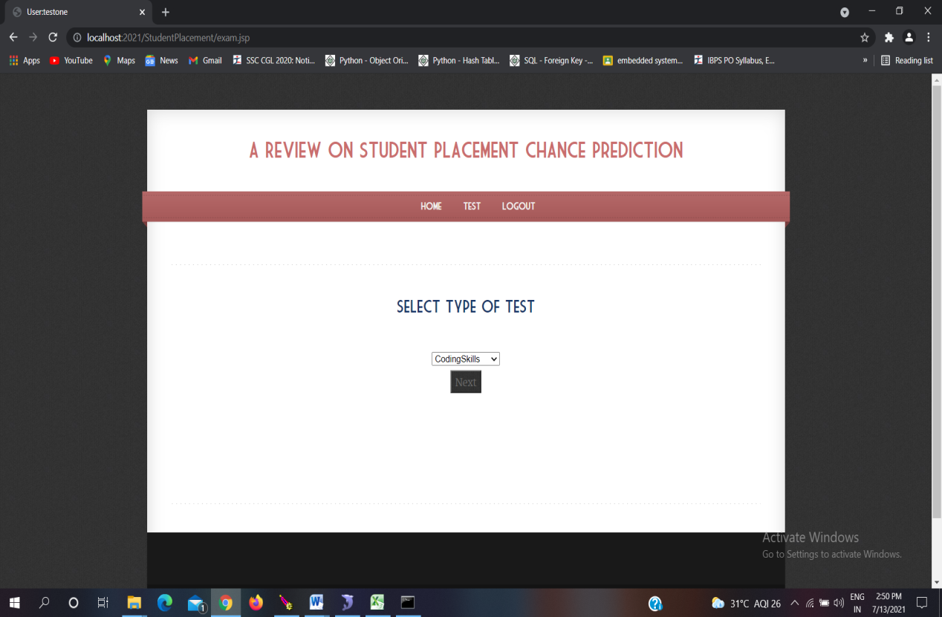

**Fig 6.11** student exam page

* The above page is to navigate between the different exams conducted by admin.



**Fig 6.12** Sample question paper

* The above page is the sample question paper page with mcqs.

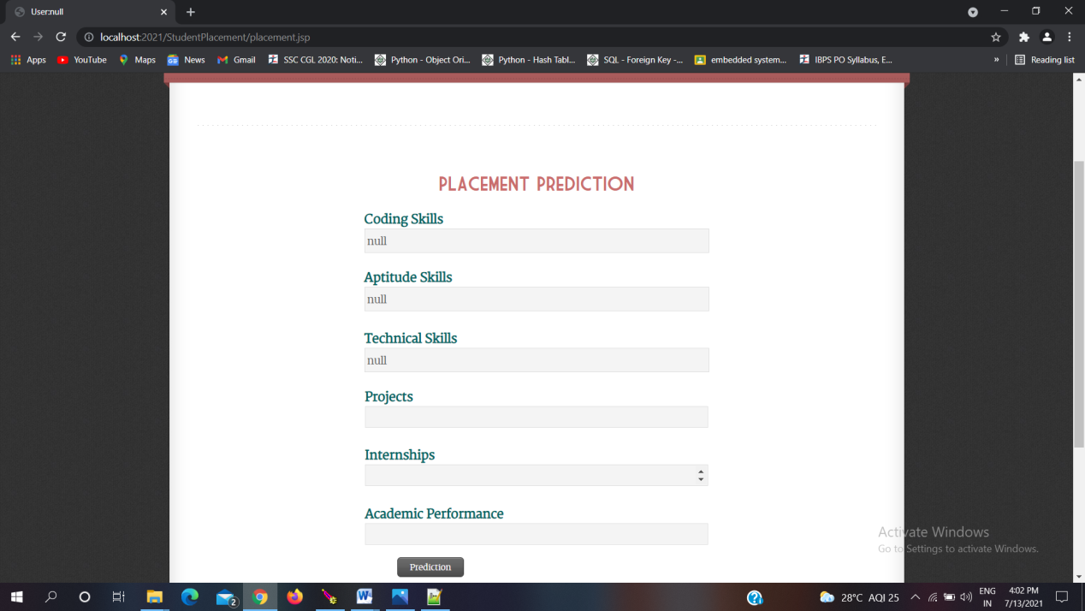

**Fig 6.13** Placement prediction

* The above page appears after the exam completion, in which student has to enter project, internship and academics details.
* And these details are given to predict.py file for testing the algorithm for data

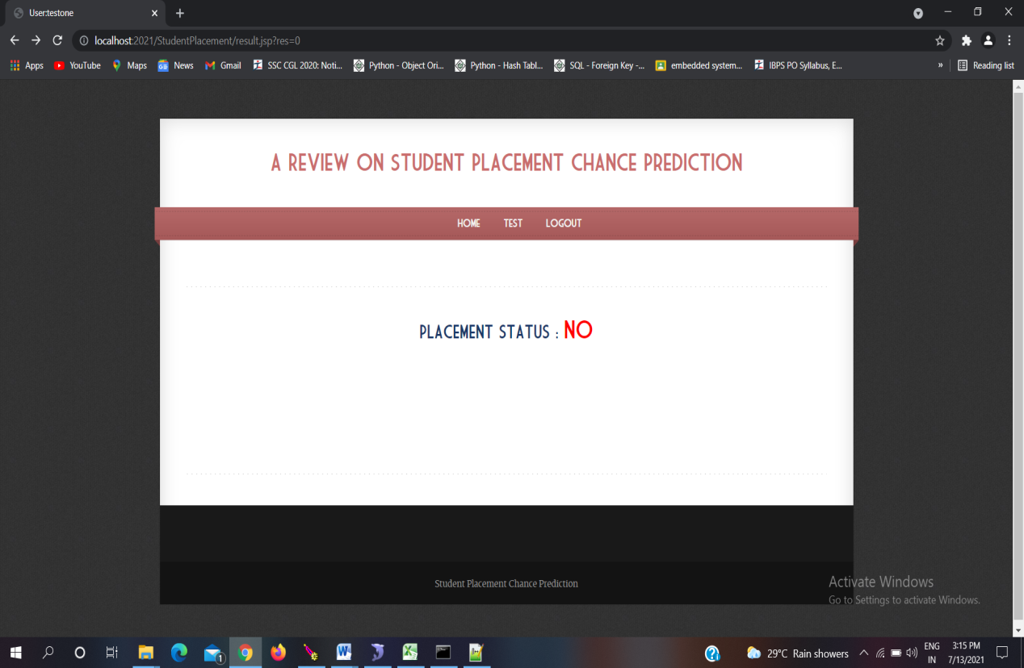

**Fig 6.14** Prediction result page

* The above page is to display the prediction for student.

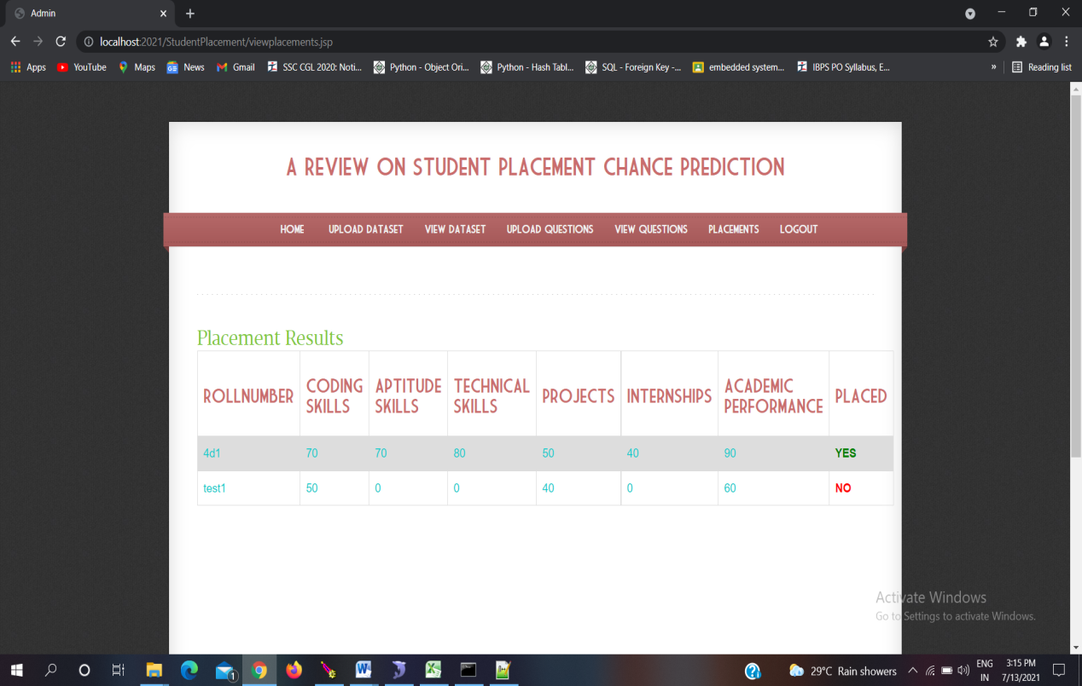

**Fig 6.15** Placement details on admin side

* The above page displays the details of all the students with their roll number and prediction.
* The above model accuracy is not calculated because the test data is not given to the algorithms directly in the form of excel sheet but given as a sample input one by one from the student point of view.
* The prediction is also stored for future references in MySQL databases.

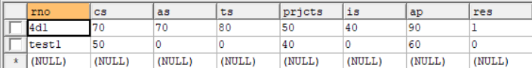

**Fig 6.16** Prediction details

* The login details of the students are also stored in MySQL databases for check the validity and future references.

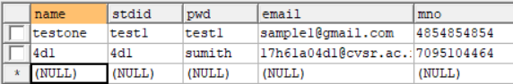

**Fig 6.17** Student details

**CHAPTER 7**

**CONCLUSION AND FUTURE SCOPE**

A detailed study was conducted based on different placement prediction models. From the study it is clear that the student dataset containing academic and placement details are a potential source for predicting the future placement chances. This prediction can enlighten students to identify their capabilities and improve accordingly. This system also helps in the academic planning of an institution to prepare proper strategies and improve the placement statistics for the future years.It would of great help if we revise and update our curriculum and other extra activities for each semester in accordance with the public, private and government sector requirement. We can also predict which company picks which category of students. Make a list of skill a particular company looking for, then on the basis of that we can train our student. These traits will make prediction process more accurate.

**CHAPTER 8**

**REFERENCES**

[1] J. Luan, “Data mining and its applications in higher education”, New Dir. Inst. Res, 113:17–36, 2002.

[2] A.S. Sharma, S. Prince, S. Kapoor, K. Kumar, “PPS – Placement prediction system using logistic regression”, IEEE international conference on MOOC, innovation and technology in education (MITE), pp 337-341,2014.

[3] Thangavel, S.Bkaratki, P. Sankar, “Student placement analyzer: A recommendation system using machine learning”, Advances in Computing and Communication Systems (ICACCS-2017) International Conference on. IEEE, 2017. [4] R. Sangha, A. Satras, L. Swamy, G. Deshmukh, “Students Placement Eligibility Prediction using Fuzzy Approach”, International Journal of Engineering and Techniques , Volume 2, Issue 6, Dec 2016.

[5] H. Bhatt, S. Mehta, L. R. D'mello, “Use of ID3 Decision Tree Algorithm for Placement Prediction”, International Journal of Computer Science and Information Technologies (IJCSIT), vol. 6, pp. 4785-4789, 2015.

[6] T. Jeevalatha, N. Ananthi, D. Saravana Kumar, “Performance analysis of undergraduate students placement selection using Decision Tree Algorithms”, International Journal of Computer Applications, vol. 108, pp. 0975-8887, December 2014.

[7] Bharambe, Yogesh, “Assessing employability of students using data mining techniques”, Advances in Computing, Communications and Informatics (ICACCI), 2017 International Conference on. IEEE, 2017.

[8] P. Khongchai, P. Songmuang, “Random Forest for Salary Prediction System to Improve Students Motivation”, 12th International Conference on SignalImage Technology & Internet-Based Systems (SITIS), pp. 637-642, 2016.

[9] Pruthi, P. Bhatia, “Application of Data Mining in Predicting Placement of Students”, International Conference on Green Computing and Internet of Things (ICGCIoT), 2015.

[10] P. Guleria, M. Sood, “Predicting Student Placements Using Bayesian Classification”, International conference on Image Information Processing, IEEE Computer Society, 2015, pp. 109- 112**.**

**CHAPTER 9**

**APPENDIX**

**Source Code:**

Database Connection:

import mysql.connector

class DBConnection:

@staticmethod

def getConnection():

database = mysql.connector.connect(host="localhost", user="root", passwd="root", db='stdntplacement')

return database

if __name__=="__main__":

print(DBConnection.getConnection())

prediction model:

from sklearn.neural_network import MLPClassifier

import numpy as np

import pandas as pd

import sys

import csv

from DBConnection import DBConnection

try:

trainset = []

database = DBConnection.getConnection()

cursor=database.cursor() cursor.execute("selectCodingSkills,AptitudeSkills,TechnicalSkills,Projects,Internships,AcademicPerformance,Placed from dataset")

row = cursor.fetchall()

y_train = []

trainset.clear()

y_train.clear()

for r in row:

x_train = []

x_train.clear()

x_train.append(float(r[0]))

x_train.append(float(r[1]))

x_train.append(float(r[2]))

x_train.append(float(r[3]))

x_train.append(float(r[4]))

x_train.append(float(r[5]))

y_train.append(r[6])

trainset.append(x_train)

trainset = np.array(trainset)

# Train the model

y_train = np.array(y_train)

cs = sys.argv[1]

ask = sys.argv[2]

ts = sys.argv[3]

prjcts = sys.argv[4]

isk = sys.argv[5]

ap = sys.argv[6]

ta=['CodingSkills','AptitudeSkills','TechnicalSkills','Projects','Internships','AcademicPerformance']

tf = [int(cs),int(ask),int(ts),int(prjcts),int(isk),int(ap)]

list = []

list.clear();

list.append(ta)

list.append(tf)

with open('live.csv', 'w') as csvFile:

writer = csv.writer(csvFile)

writer.writerows(list)

csvFile.close()

tf = pd.read_csv('live.csv')

testdata = np.array(tf)

# print("Ped=",testdata)

testdata = testdata.reshape(len(testdata), -1)

#print("Pedd=", testdata)

# ANN

clf = MLPClassifier()

clf.fit(trainset, y_train)

result = clf.predict(testdata)

print(result[0])

except Exception as e:

print("Error=" + e.args[0])

tb = sys.exc_info()[2]

print(tb.tb_lineno)

Converion of excel data to database:

package CT;

import databaseconnection.*;

import java.io.*;

import org.apache.poi.hssf.usermodel.HSSFWorkbook;

import org.apache.poi.hssf.usermodel.HSSFSheet;

import org.apache.poi.ss.usermodel.*;

import org.apache.poi.xssf.usermodel.XSSFSheet;

import org.apache.poi.xssf.usermodel.XSSFWorkbook;

import javax.swing.JOptionPane;

import java.util.*;

import java.sql.*;

public class XLToDB {

public static final String INSERT_RECORDS = "INSERT INTO dataset VALUES(?,?,?,?,?,?,?)";

public static boolean insertRecords(String s){

File f=new File(s);

/* Create Connection objects */

Connection con = null;

PreparedStatement prepStmt = null;

java.sql.Statement stmt = null;

int count = 0;

ArrayList<String> mylist = new ArrayList<String>();

try{

con =databasecon.getconnection();

System.out.println("Connection :: ["+con+"]");

prepStmt = con.prepareStatement(INSERT_RECORDS);

stmt = con.createStatement();

count = 1;

FileInputStream fis = new FileInputStream(f);

XSSFWorkbook workbook = new XSSFWorkbook (fis);

XSSFSheet sheet = workbook.getSheetAt(0);

Iterator ite = sheet.rowIterator();

while(ite.hasNext()) {

Row row = (Row) ite.next();

if(row.getRowNum()==0){

continue;

}

Iterator<Cell> cellIterator = row.cellIterator();

int index=1;

int c=1;

while(cellIterator.hasNext()) {

Cell cell = cellIterator.next();

//System.out.println("getting cell value..! ");

switch(cell.getCellType()) { case Cell.CELL_TYPE_STRING: //handle string columns //System.out.println("in case1-- "+(index));

prepStmt.setString((index), cell.getStringCellValue());

break;

case Cell.CELL_TYPE_NUMERIC: //handle double data

int i = (int)cell.getNumericCellValue()

prepStmt.setInt((index), (int) cell.getNumericCellValue()); //System.out.println("in case1 "+(index));

break;

}

index++;

c++;

}

count++;

//we can execute the statement before reading the next row

try{

int i= prepStmt.executeUpdate();

if(i>=1){

//System.out.println("inseted");

}

}

catch(Exception e){

System.out.println(e);

}

}

/* Close input stream */

fis.close();

/* Close prepared statement */

prepStmt.close();

/* Close connection */

con.close();

}catch(Exception e){

e.printStackTrace();

}

return true;

}

}